GIS:

1. Check if all the tables have a primary key (pk). If not, set the pk for each table by Sql developer.
2. Join tables to get the view, including both pk.
3. Open ArcCatalog, right click on the view, and click “register with geodatabase”, and register it with geodatabase.
4. The view is ready, and it’s editable.

User:

1. Open ArcMap. Add the view. Click the Editor 🡪 Options.

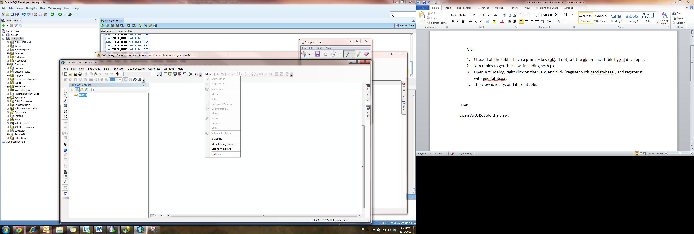

1. Under Versioning. Uncheck “Edit a version of database with the ability to undo and redo.”

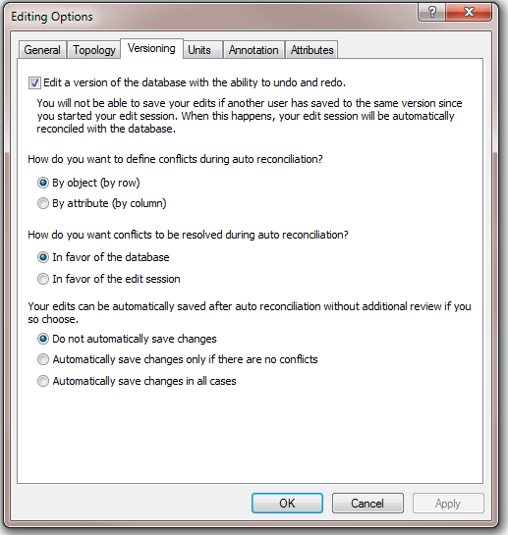

1. Done.

Note: users need to uncheck the box of versioning each time they open ArcMap.

A view can not be versioned.